Dressage Tasmania Horse of the Year 2023-24 Nomination Form

Horse, Pony, Young Rider, Off the Track Thoroughbred and Off the Track Standardbred
Please complete and return this form to: dressagetasmania@outlook.com
NOMINATIONS CLOSE FRIDAY 17th MAY 2024

Horse, Pony and Young Rider of the year will be awarded to the horse/pony/young rider who has gained the highest average percentage from 4 official performances at one level within the performance period (YR performances may come from any level).
Winner will receive an embroidered trophy rug, runner-up will receive an embroidered saddle blanket.

Performance Period: 6th March 2023 to 3rd March 2024 (inclusive)

Eligibility:
During the ‘Performance Period’:
- Horse/Pony must have been EA registered and hold an EA competition license
- Rider must be a current member of Dressage Tasmania.
- Horse and rider must reside in Tasmania.
- Performances must be obtained in Tasmania within the performance period.
- One performance may be included from National or Interstate Championships or CDI competitions whilst representing Tasmania.
- Ponies must have obtained a current official EA height certificate (please attach).

Performance Criteria:
- Preliminary to Advanced: Must provide 4 Official Performances at one level
(may nominate for more than 1 level)
- FEI: Must provide 2 Performances at small/medium/ big tour
- Young Rider: Must provide 4 Official Performances across any level
- Off the Track Must provide 4 Official Performances across any level. Horse must be registered with Australian Register of Racehorses
**FEI Small/Med/Big Tour; for the purposes of this award is defined as competing either level e.g. PSG/I1, Inter A/B, I2/GP.

Rider Name:
EA Member Number:
Address:

Phone:
Email:
Horse Name:
EA Number:
Current Grading:
Rug Size:
Horse Pony Young Rider Off the Track Thoroughbred
Off the Track Standardbred (please circle)

Performances:
Please include a screenshot of official performances. Results from the EA website and dressage results search are preferred, but you may also include screenshots from the Nominate Scoreboard app.

To search for results. go to:
http://www.equestrian.org.au/members/search/dressage-results

Search for your horse’s name with the dates as above and attach to this form.

Please highlight your 4 best scores (or 2 for FEI) within the performance period.
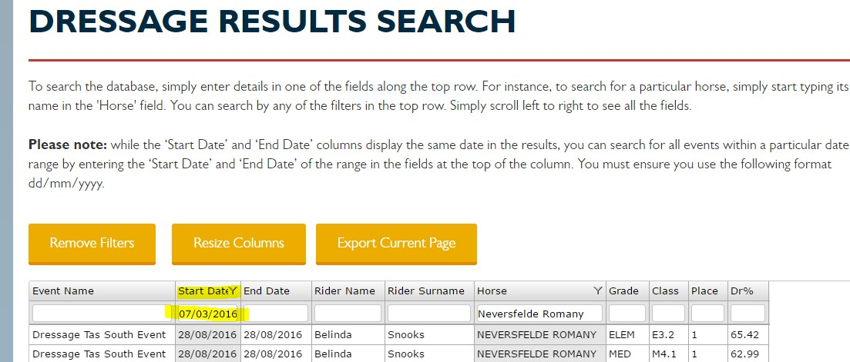
Example

